MAIA UAT Form - Holsen - March 2026 Copy

MAIA User Acceptance Test (UAT) — Holsen

March 2026 · Round 1

Before You Start
UAT Period: 18 March 2026 – 25 March 2026
Sign-Off Deadline: 25 March 2026
Go-Live (Core MAIA): 31 March 2026

UAT Timeline
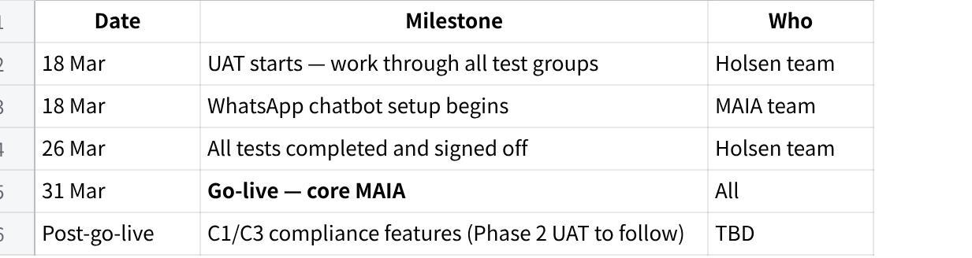
点击图片可查看完整电子表格
Scope note: This UAT covers core MAIA only. C1/C3 compliance features and A57 tax exemption enforcement are not included in this round — they will be tested separately after go-live.
Web App: https://maia-fe-holsen.vercel.app/login
Chatbot (during UAT): Telegram — scan the QR code provided to open the MAIA Holsen chatbot
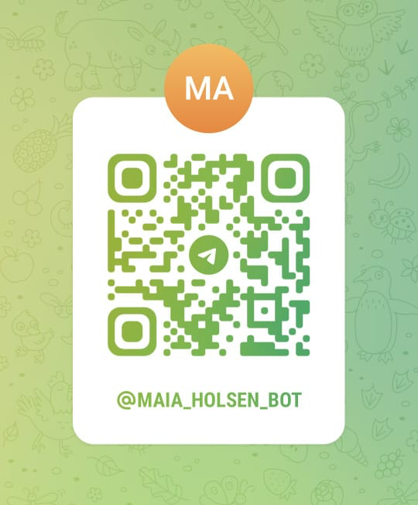
Chatbot (after go-live): WhatsApp (same features — WhatsApp setup is in progress)

Your Login Details
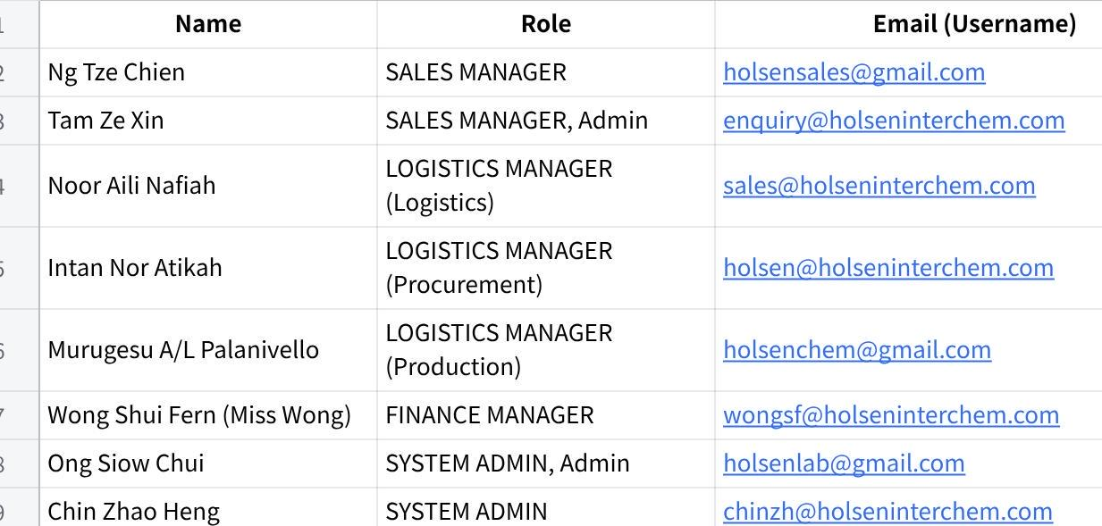
点击图片可查看完整电子表格

How to Use This Document
- Work through each test in order — some tests use data created in earlier steps.
- For each step, do what is described and check that what you see matches the "What you should see" column.
- After each test, tick your result and write any notes in the feedback box.
- If something does not work as expected, mark it Fail and describe what happened.
- If you are unsure or something is not loading, mark it Issue and contact Gareth.
- Sign off at the end when you are done.
About these test cases: All tests in this document are based on the agreed MAIA scope in the Holsen SOW. If any test case does not match how your business works, or if you notice a step that seems incorrect, please do not guess — contact Gareth directly and we will review and update the test case before you proceed.
Result options:
- ✅ Pass — Everything worked as described
- ❌ Fail — Something did not work correctly
- ⚠️ Issue — Could not complete the test (e.g., button missing, page not loading)

Reporting issues:
- If you find a bug or something is not working correctly, use Jam to record your screen and share the issue with us.
-> How to Record and Share Issues with Jam
- Copy the link and share it in the test cases or in the group

Setup Checklist (For MAIA team to complete before UAT starts)
- All user accounts created and login details filled in above
- Customer records loaded (at least 3 test customers with name and address)
- Product catalogue loaded (at least 5 products with descriptions and pricing)
- Stock quantities loaded (at least 1 product at zero stock, 1 at low-stock level)
- Low-stock threshold configured (Safety Qty in Item)
- Delivery delay reminder threshold configured
- At least 1 product flagged as Poison in the system
- Test customer has full address and phone number

Tests

Group 1 — Chatbot: Sending Orders

Test 1 — Send an Order by Text Message
Who tests this: Ng Tze Chien or Tam Ze Xin (Sales Manager)
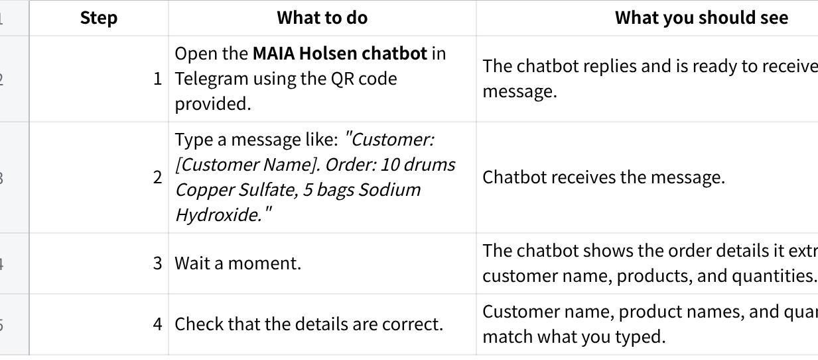
点击图片可查看完整电子表格
Your result:
- Pass
- Fail
- Issue
Tested by: Tam
Date: 26/5/26
Notes:

Test 2 — Send an Order by Photo
Who tests this: Ng Tze Chien or Tam Ze Xin (Sales Manager)
[电子表格下载失败]
Your result:
- Pass
- Fail
- Issue
Tested by: Tam
Date: 14/5/26
Notes:

Test 3 — Send an Order by PDF
Who tests this: Ng Tze Chien or Tam Ze Xin (Sales Manager)
[电子表格下载失败]
⚠️ Note: After the chatbot confirms the CPO is created, go to the web app to review the extracted details and convert the CPO to a Sales Order. This is covered in the Group 2 web app tests.
Your result:
- Pass
- Fail
- Issue
Tested by: Tam
Date: 14/5/26
Notes:

Test 4 — Pricing and Stock Check
Who tests this: Ng Tze Chien or Tam Ze Xin (Sales Manager) — continue from Test 1, 2, or 3.
[电子表格下载失败]
Your result:
- Pass
- Fail
- Issue
Tested by: Tam
Date: 28/4/26
Notes:

Group 2 — Web App: Managing Orders

Test 5 — Generate Documents (Quotation → Sales Order → Proforma Invoice → Invoice)
Who tests this: Ng Tze Chien / Tam Ze Xin (Sales Manager) for Step 1; Noor Aili (Logistics) or Miss Wong (Finance) for Steps 2–5
Continue from the order created in Test 4. Different roles handle different steps — coordinate as needed.
Why different roles? Sales Manager can create Quotations but cannot create or edit Sales Orders (view only). SO creation and Invoice submission must be done by Logistics or Finance.
[电子表格下载失败]
Your result:
- Pass
- Fail
- Issue
Tested by: Tam (Aili, Wong)
Date: 14/4/26
Notes:

Test 6 — Create a Credit Note and Debit Note
Who tests this: Miss Wong (Finance)
Use an existing Invoice from Test 5.
[电子表格下载失败]
Your result:
- Pass
- Fail
- Issue
Tested by: Tam (Wong)
Date: 14/4/26
Notes:

Test 7 — Duplicate Order is Blocked
Who tests this: Ng Tze Chien or Tam Ze Xin (Sales Manager)
Note: The duplicate check triggers when an existing order with the same PO number is already in TO BILL (submitted) status. Draft orders are not checked.
[电子表格下载失败]
Your result:
- Pass
- Fail
- Issue
Tested by: Tam
Date: 26/5/26
Notes:
Unable to proceed due to test 2 and test 3 not working.

Test 8 — Manage Sales Orders on the Web App
Who tests this: Noor Aili (Logistics) or Miss Wong (Finance) for SO creation; Ng Tze Chien (Sales Manager) for view-only check
Note: Sales Manager has view-only access to Sales Orders. SO creation and editing is done by Logistics (Noor Aili) or Finance (Miss Wong).
[电子表格下载失败]
Your result:
- Pass
- Fail
- Issue
Tested by: Tam (Aili, Ng)
Date: 14/4/26
Notes:

Test 9 — Export Sales Order / Sales Invoice / Delivery Note as CSV
Who tests this: Admin
Exports these document types from MAIA as CSV files for downstream processing and checking.
[电子表格下载失败]
⚠️ Note: This test is to confirm that the required document types can be exported correctly as CSV from MAIA.
Your result:
- Pass
- Fail
- Issue
Tested by:
Date:
Notes:

Group 3 — Logistics: Deliveries and Stock Alerts

Test 10 — Create a Delivery Order and Picking List
Who tests this: Noor Aili (Logistics)
[电子表格下载失败]
Your result:
- Pass
- Fail
- Issue
Tested by: Tam (Aili)
Date: 14/4/26
Notes:
Pick list pdf : SO ref & warehouse not important
Require batch number / barcode

Test 10A — Delivery Note Batch Number Carries Over to Pick List
Who tests this: Noor Aili (Logistics)
[电子表格下载失败]
Your result:
- Pass
- Fail
- Issue
Tested by:
Date:
Notes:

Test 10B — Exact Selected Batch Number Stays Correct and Visible in Pick List
Who tests this: Noor Aili (Logistics)
[电子表格下载失败]
Your result:
- Pass
- Fail
- Issue
Tested by:
Date:
Notes:

Test 11 — Stock Alerts (Out of Stock and Low Stock)
Who tests this: Noor Aili (Logistics) and Ng Tze Chien / Tam Ze Xin (Sales Manager) — both should see the alerts
[电子表格下载失败]
Your result:
- Pass
- Fail
- Issue
Tested by: Tam (Aili)
Date: 28/4/26
Notes:
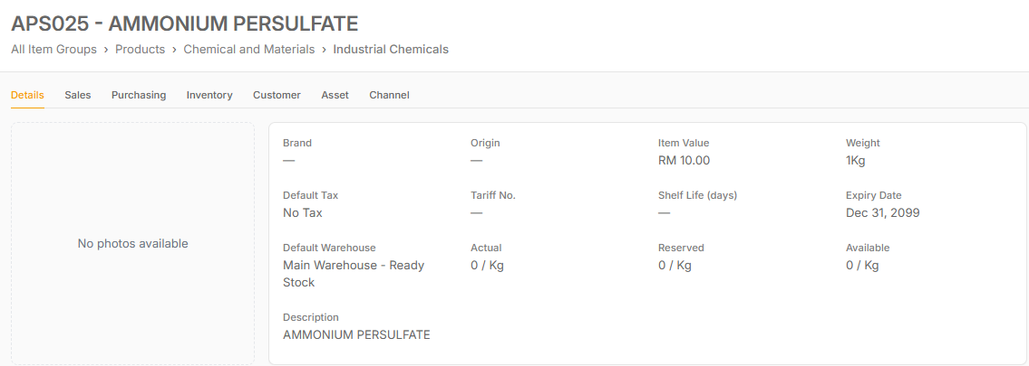
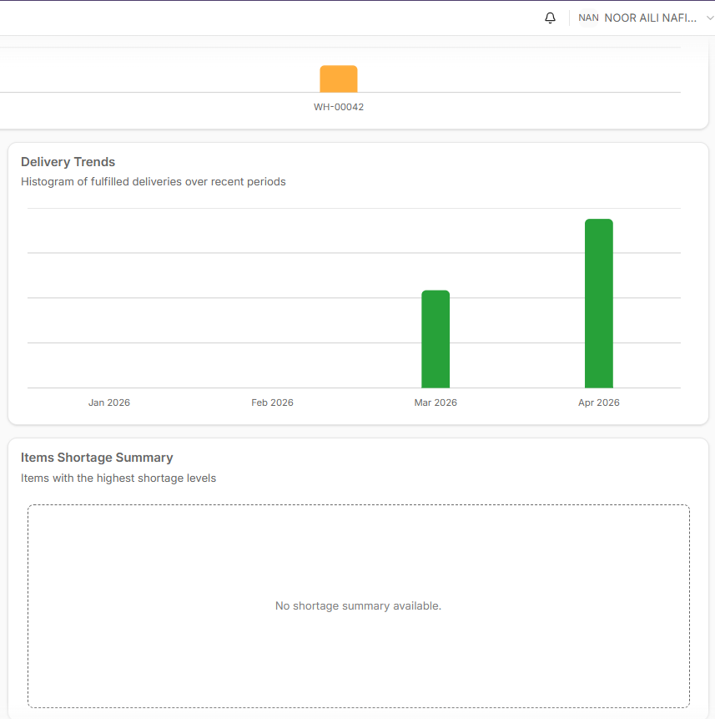
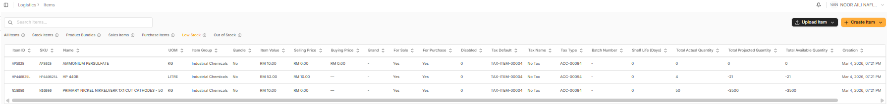
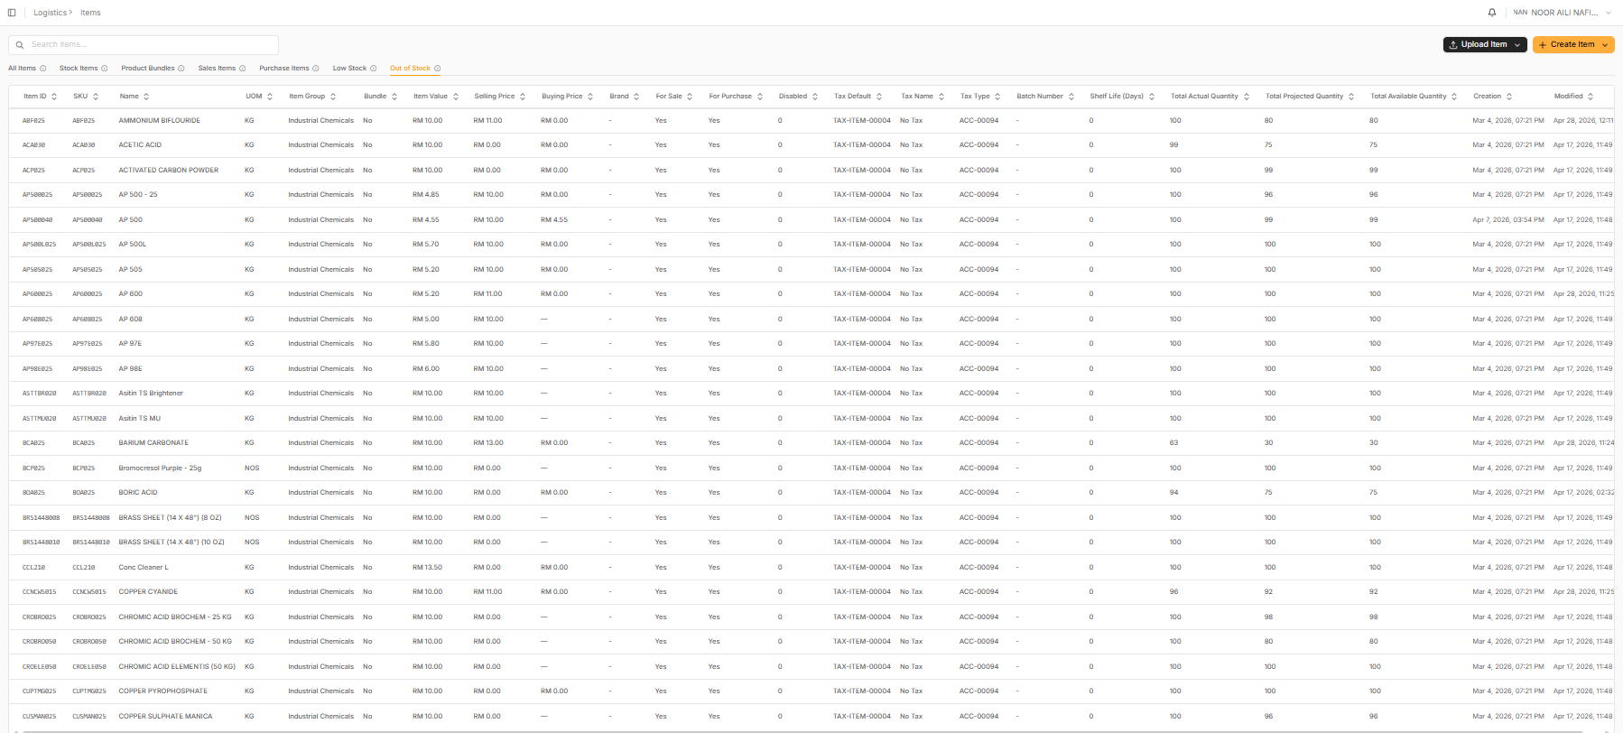
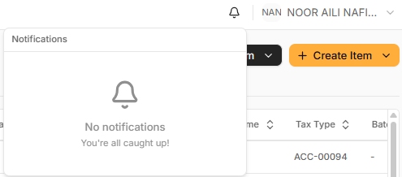
Tested on item ammonium persulfate. Did stock recon to 0 quantity. No notification popup. Item does not show up in Out Of Stock tab. Shows up in Low Stock tab instead. Same with ammonium bifluoride. No alerts or notification even after stock falls below the safety stock limit.

Low stock tab and out of stock tab reverse
Noor aili logistics manager, no notification

Test 12 — Delivery Delay Reminder
Who tests this: Noor Aili (Logistics)
[电子表格下载失败]
⚠️ Note: If you cannot find an overdue Invoice to test this, please contact Gareth to set one up.
Your result:
- Pass
- Fail
- Issue
Tested by:
Date:
Notes:

Group 4 — Logging In

Test 13 — All Users Can Log In
Who tests this: Everyone — all 8 users log in with their own account
[电子表格下载失败]
Your result:
- Pass
- Fail
- Issue
Tested by:
Date:
Notes:

Group 5 — What Each Person Can and Cannot Do
Each person tests their own account. Check that you can do the things listed, and that you are blocked from things outside your role.

Test 14 — Sales Manager Access Check
Who tests this: Ng Tze Chien or Tam Ze Xin (Sales Manager)
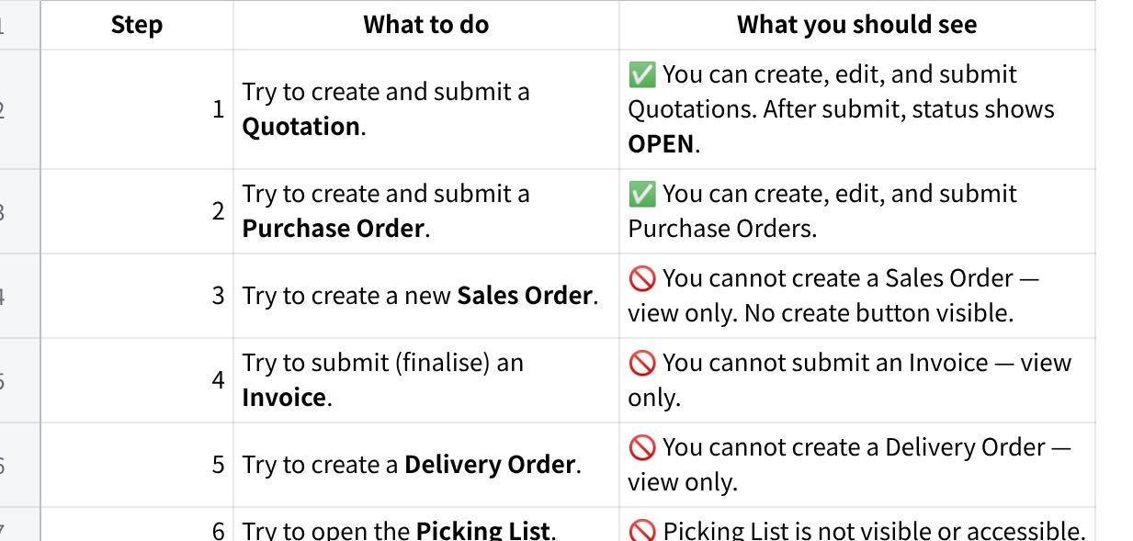
点击图片可查看完整电子表格
Your result:
- Pass
- Fail
- Issue
Tested by: Tam (Ng acct)
Date: 14/4/26
Notes (list any step that did not behave as expected):

Test 15 — Logistics / Operations Access Check
Who tests this: Noor Aili (Logistics — Operations)
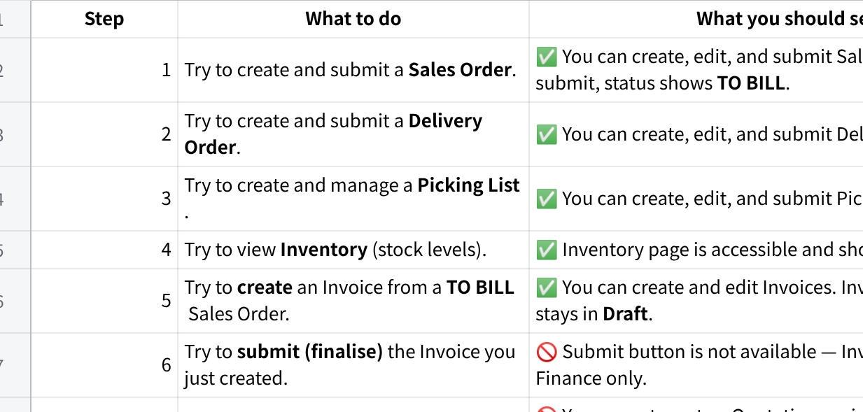
点击图片可查看完整电子表格
Your result:
- Pass
- Fail
- Issue
Tested by: Tam
Date: 14/4/26
Notes (list any step that did not behave as expected):
- Qty shown up in DO is different from the qty in sales order. Could be because managed to update the Wt UOM to 50kg.
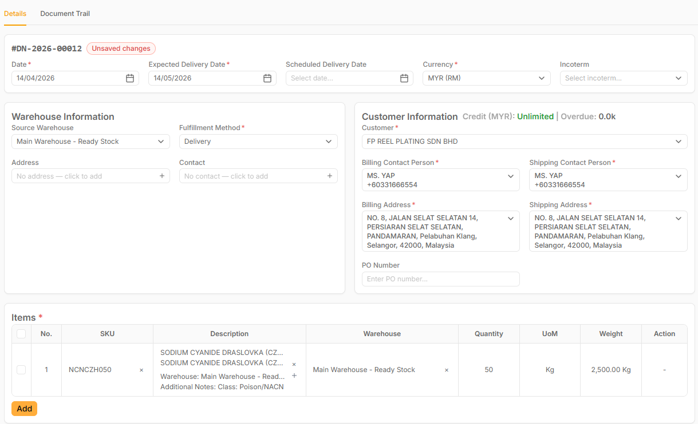
- Possible to leave out the warehouse info from the pick list? Not necessary for current practice.

Test 16 — Logistics / Procurement Access Check
Who tests this: Intan Atikah (Logistics — Procurement)
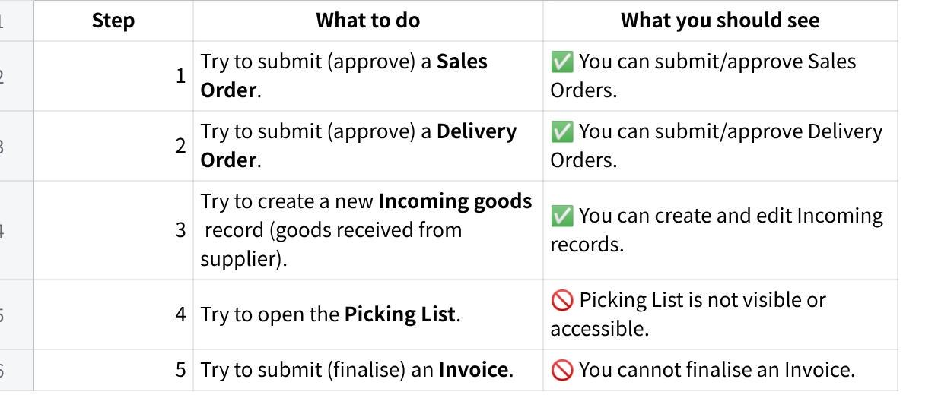
点击图片可查看完整电子表格
Your result:
- Pass
- Fail
- Issue
Tested by: Tam
Date: 1/4/26
Notes (list any step that did not behave as expected):

Test 17 — Logistics / Production Access Check
Who tests this: Murugesu (Logistics — Production)
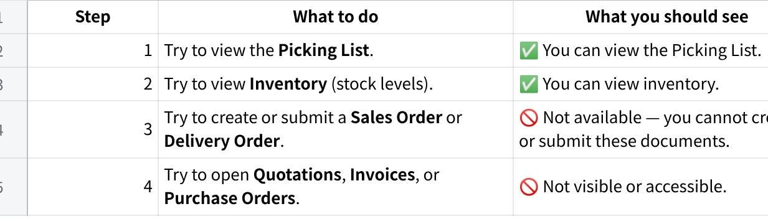
点击图片可查看完整电子表格
Your result:
- Pass
- Fail
- Issue
Tested by:
Date:
Notes (list any step that did not behave as expected):
Please remove access to customer list

Test 18 — Finance Manager Access Check
Who tests this: Miss Wong (Finance)
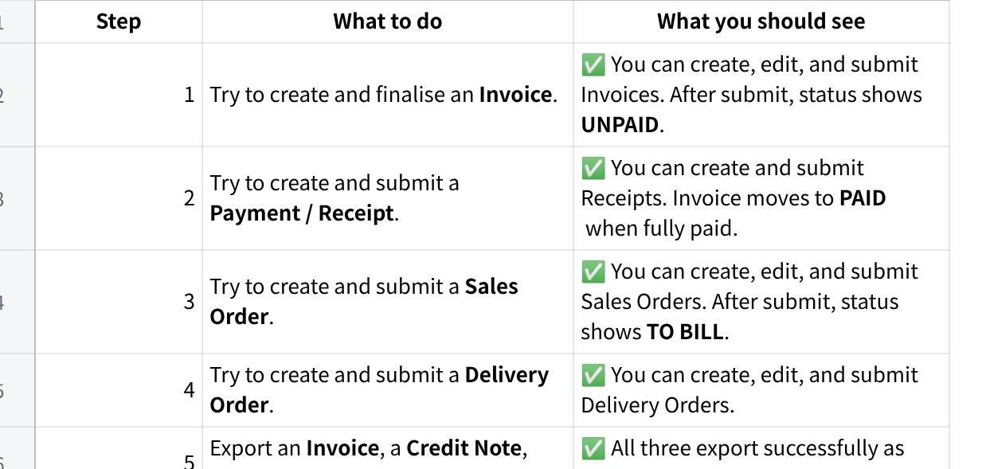
点击图片可查看完整电子表格
Your result:
- Pass
- Fail
- Issue
Tested by:
Date:
Notes (list any step that did not behave as expected):

Test 19 — Admin Access Check
Who tests this: Ong Siow Chui or Tam Ze Xin (Admin)
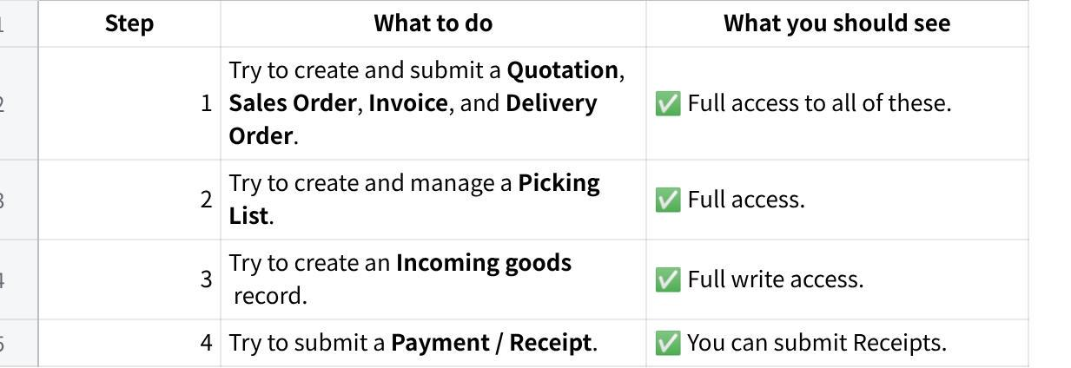
点击图片可查看完整电子表格
Your result:
- Pass
- Fail
- Issue
Tested by:
Date:
Notes (list any step that did not behave as expected):

Test 20 — System Admin Access Check
Who tests this: Chin Zhao Heng (System Admin)
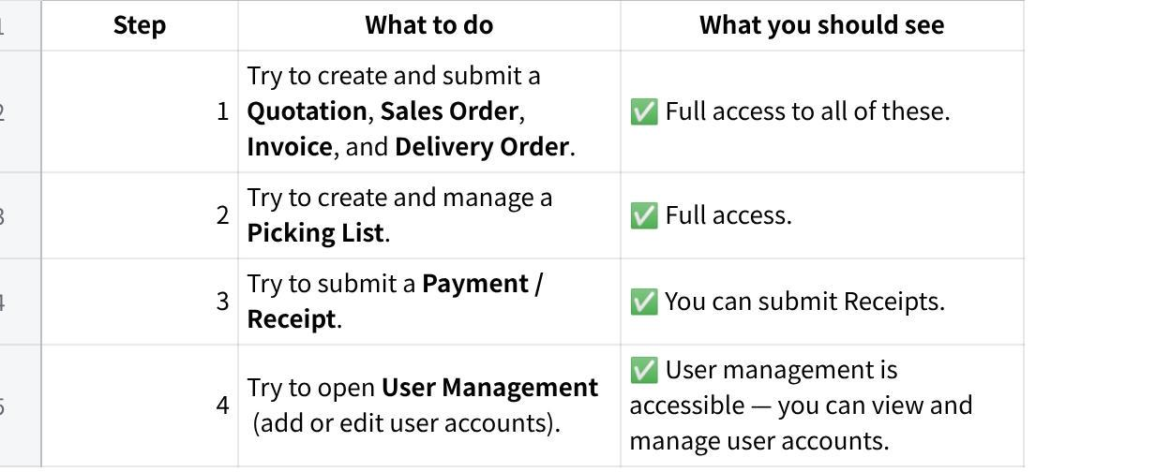
点击图片可查看完整电子表格
Your result:
- Pass
- Fail
- Issue
Tested by:
Date:
Notes (list any step that did not behave as expected):
Cannot edit minimum price for items

Test 21 — Role Approval Flow
Who tests this: All roles — coordinate as a group across all steps
Part A — Quotation & Purchase Order (Sales Manager submits)
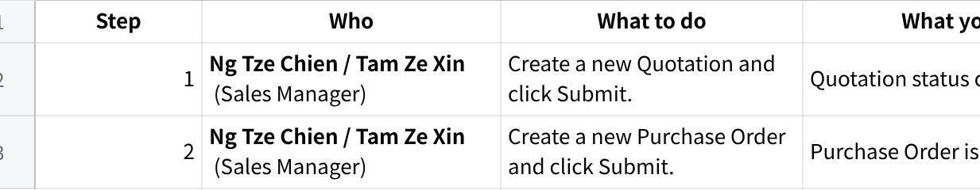
点击图片可查看完整电子表格
Part B — Sales Order submission (Logistics and Finance can create and submit)
Note: Sales Manager has view-only access on Sales Orders — SO drafts are created by Logistics or Finance.
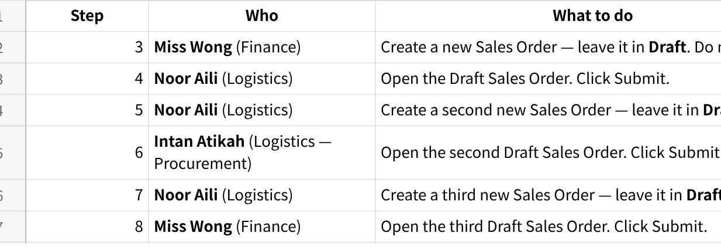
点击图片可查看完整电子表格
Part C — Delivery Order submission (Logistics and Finance can submit)
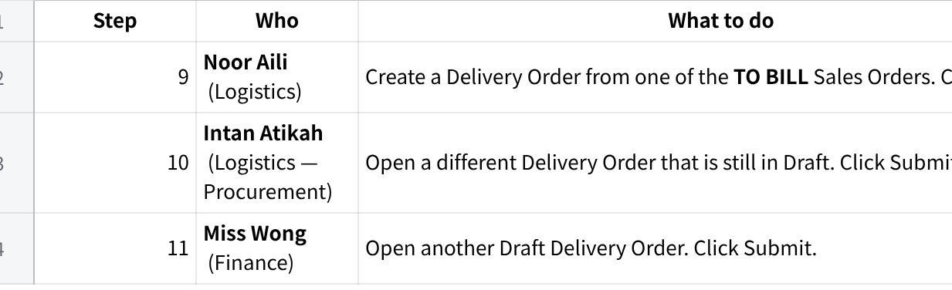
点击图片可查看完整电子表格
Part D — Pick List submission (Logistics — Noor Aili)
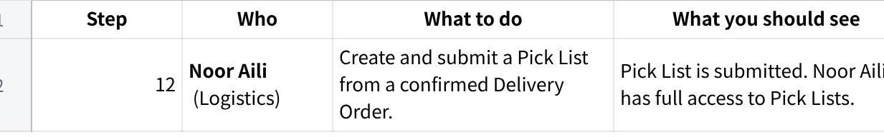
点击图片可查看完整电子表格
Part E — Invoice submission (Finance submits)
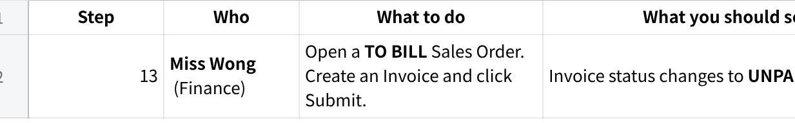
点击图片可查看完整电子表格
Part F — Receipt / Payment submission (Finance creates; Finance and Admin can submit)
Note: Admin can submit Receipts but cannot create them. Finance (Miss Wong) creates the Receipt; Admin can then submit it.
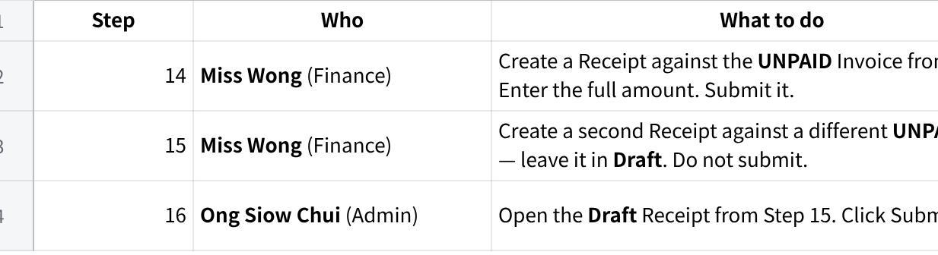
点击图片可查看完整电子表格
Your result:
- Pass
- Fail
- Issue
Tested by: (coordinate across team)
Date:
Notes (note the step number if any step failed):

Group 6 — Poison Signed Order (PSO)
What is this? Holsen requires to attach a signed Poison Signed Order (PSO) form to every delivery that contains poison products. MAIA generates this form automatically when needed.

Test 22 — Poison Signed Order (PSO) — Full Test
Who tests this: Noor Aili (Logistics) or Tam Ze Xin (Admin)
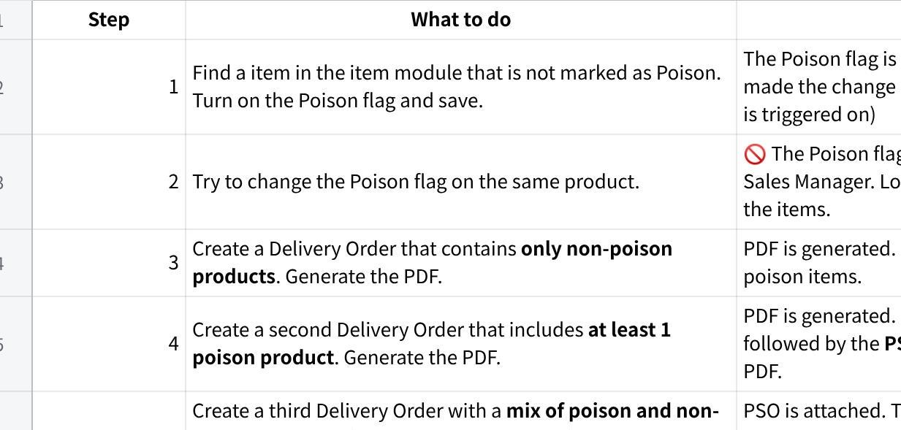
点击图片可查看完整电子表格
Your result:
- Pass
- Fail
- Issue
Tested by: TAM
Date: 11/5/26
Notes (if any step failed, note the step number and describe what happened):\

Test 23 — Tagging and Trading Item Price Prompt Alert
Who tests this: Ng Tze Chien or Tam Ze Xin (Sales Manager)
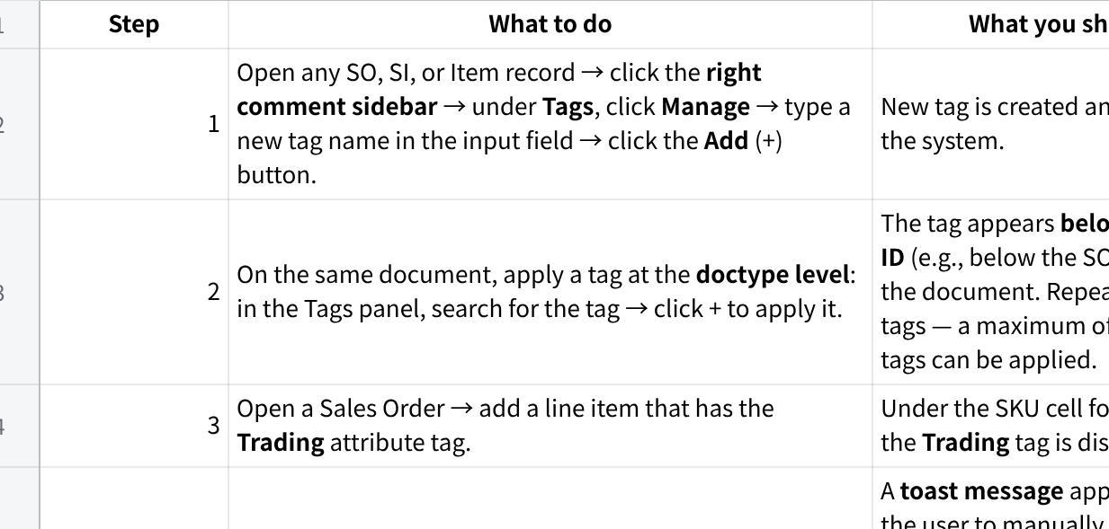
点击图片可查看完整电子表格
Your result:
- Pass
- Fail
- Issue
Tested by: Tam
Date:
Notes:

Group 7: Tax Reference / Certificate (C1 & C3)

Test 24 — Upload C1 Certificate via PDF
Who tests this: [Admin] or [Sales Manager]
Channel: FE + Chatbot
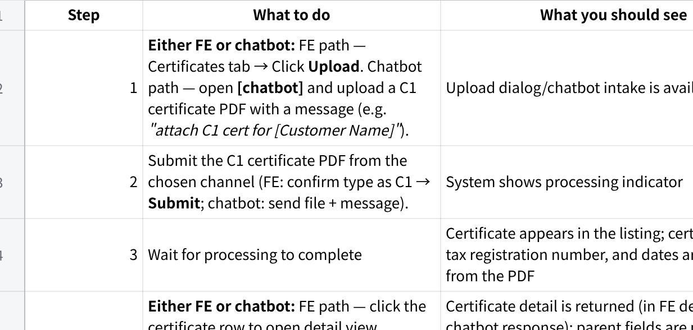
点击图片可查看完整电子表格
Your result:
- Pass
- Fail
- Issue
Tested by: Tam
Date: 26/5/26
Notes: Uploaded C1 cert for Guan Huat

Test 25 — Apply C1 Certificate on Sales Order — All Items Covered
Who tests this: [Sales Manager] or [Finance / Logistics]
Channel: FE + Chatbot
Part A — Get the Sales Order via Chatbot
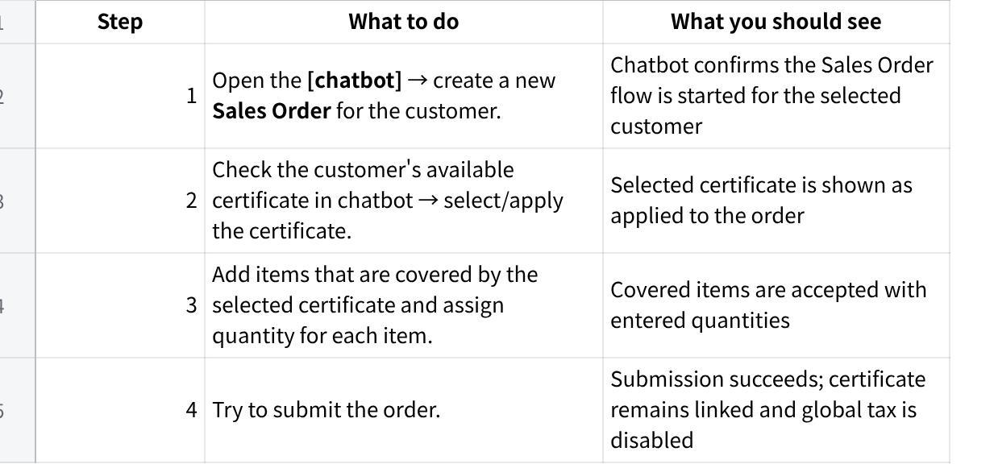
点击图片可查看完整电子表格
Part B — Get the Sales Order via Web App
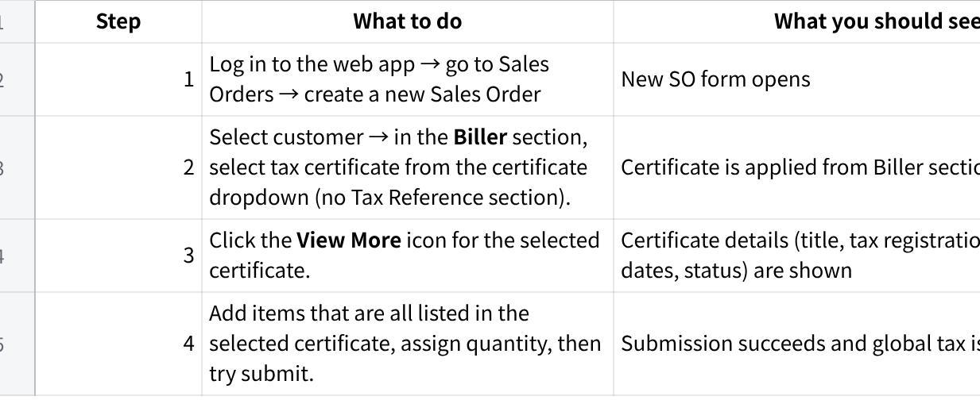
点击图片可查看完整电子表格
Your result:
- Pass
- Fail
- Issue
Tested by:
Date:
Notes:

Test 26 — Apply C1 Certificate — Partial Coverage + Save
Who tests this: [Sales Manager] or [Finance / Logistics]
Channel: FE + Chatbot
Part A — Get the Sales Order via Chatbot
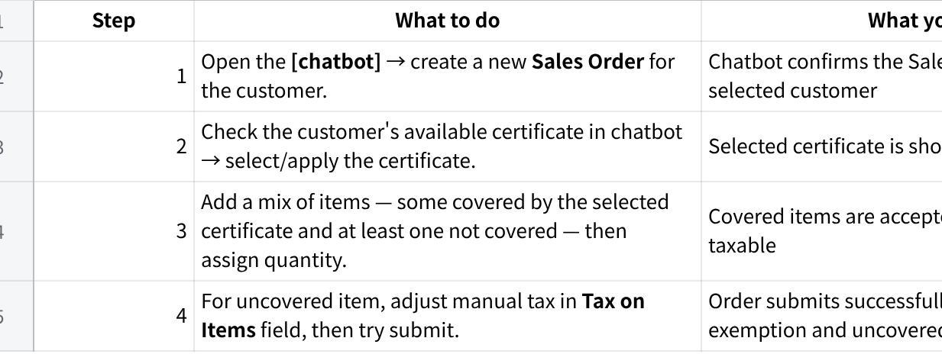
点击图片可查看完整电子表格
Part B — Get the Sales Order via Web App
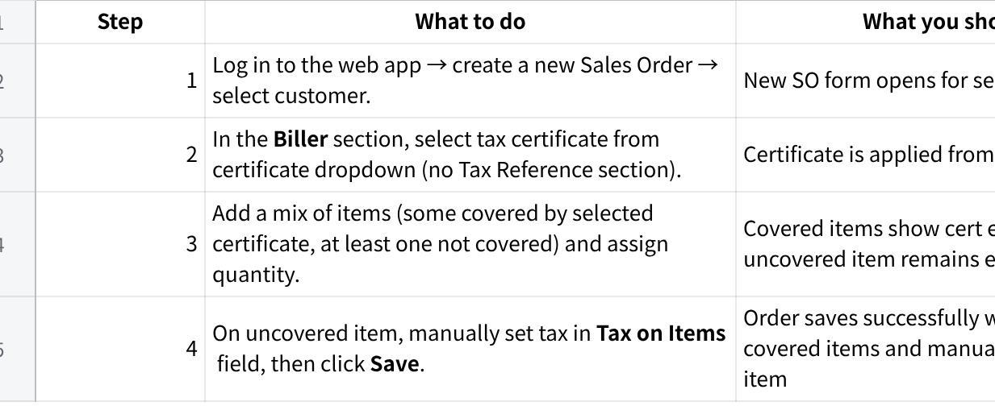
点击图片可查看完整电子表格
Your result:
- Pass
- Fail
- Issue
Tested by:
Date:
Notes:

Test 27 — Upload C3 Certificate via PDF
Who tests this: [Admin] or [Sales Manager]
Channel: FE + Chatbot
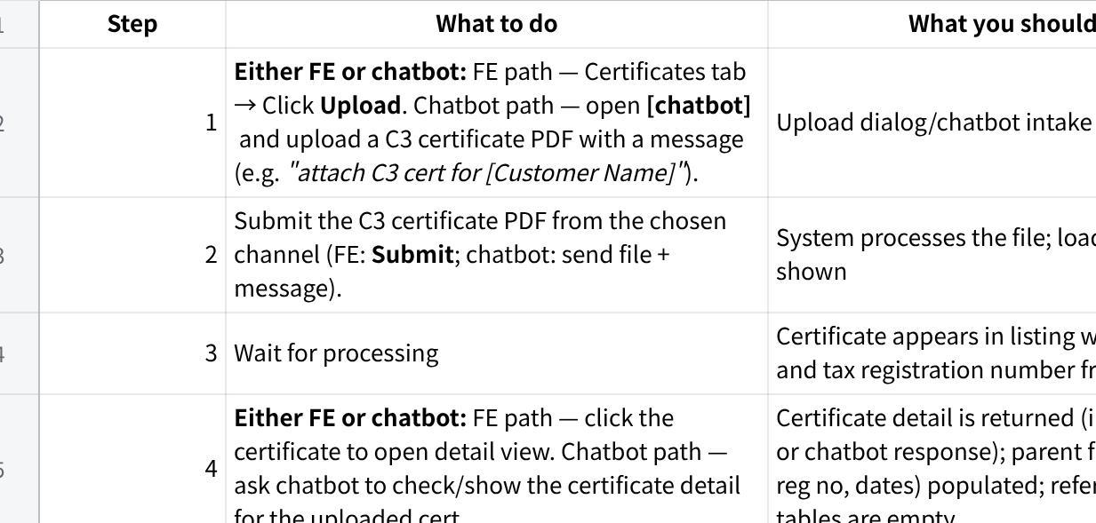
点击图片可查看完整电子表格
Your result:
- Pass
- Fail
- Issue
Tested by: Tam
Date: 26/5/26
Notes: Uploaded C3 cert for Guan Huat

Test 28 — Apply C3 Certificate on Sales Order — All Items Covered
Who tests this: [Sales Manager] or [Finance / Logistics]
Channel: FE + Chatbot
Part A — Get the Sales Order via Chatbot
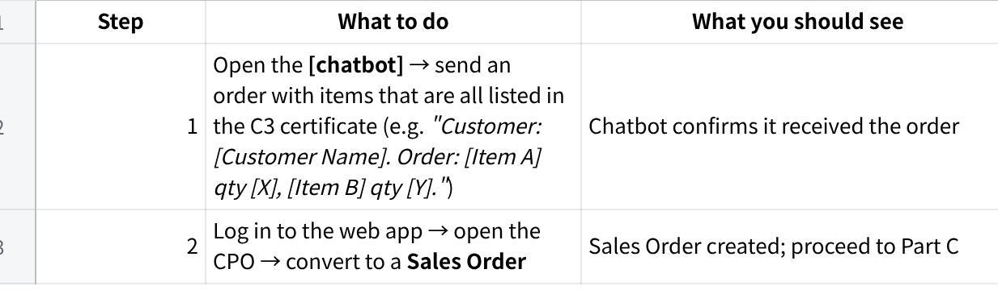
点击图片可查看完整电子表格
Part B — Get the Sales Order via Web App
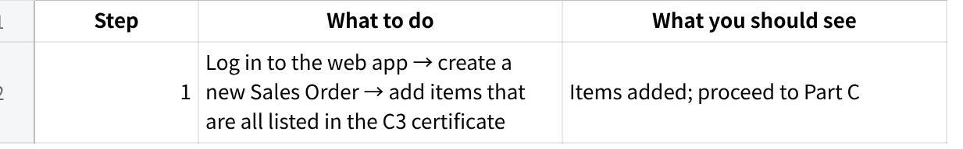
点击图片可查看完整电子表格
Part C — Apply C3 Certificate (both paths continue here)
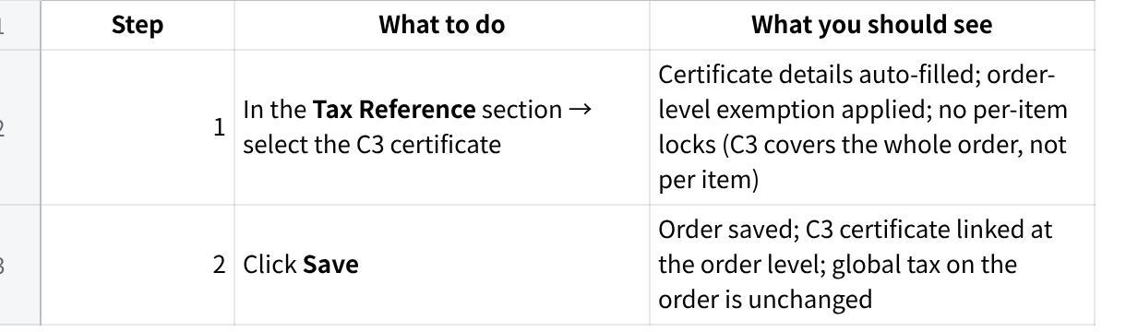
点击图片可查看完整电子表格
Your result:
- Pass
- Fail
- Issue
Tested by: Tam
Date: 26/5/26
Notes:

Test 29 — C3 Certificate — Ineligible Items Removal Prompt
Who tests this: [Sales Manager] or [Finance / Logistics]
Channel: FE + Chatbot
Part A — Get the Sales Order via Chatbot
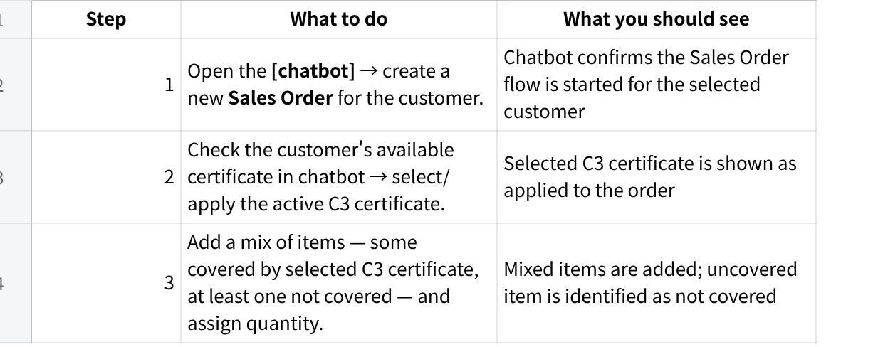
点击图片可查看完整电子表格
Part B — Get the Sales Order via Web App
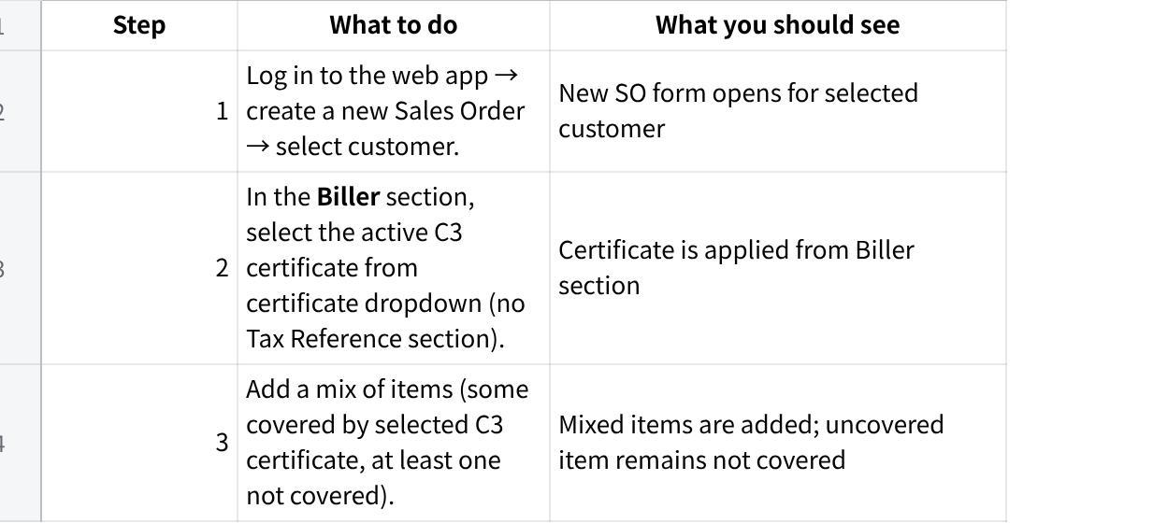
点击图片可查看完整电子表格
Part C — Apply C3 Certificate and Test Removal Prompt (both paths continue here)
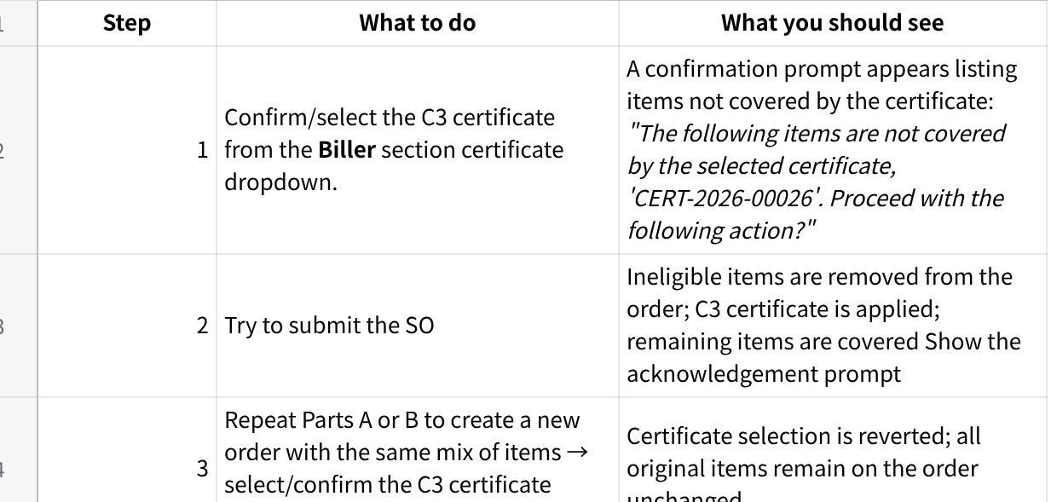
点击图片可查看完整电子表格
Your result:
- Pass
- Fail
- Issue
Tested by:
Date:
Notes:

Test 30 — Link Certificate to CPO at Upload Time (C1 + C3)
Who tests this: [Admin] or [Sales Manager]
Channel: FE + Chatbot
Part A — via Chatbot
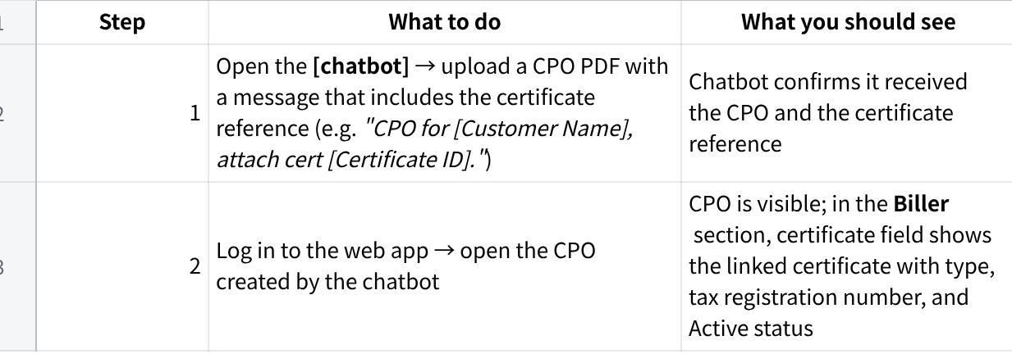
点击图片可查看完整电子表格
Part B — via Web App
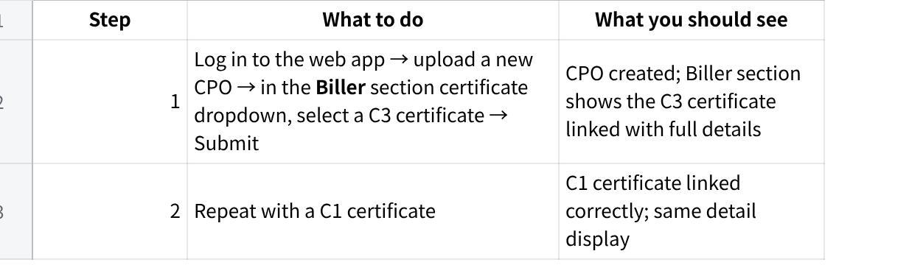
点击图片可查看完整电子表格
Your result:
- Pass
- Fail
- Issue
Tested by:
Date:
Notes:

Test 31 — CPO with Certificate Converts to SO — Cert Carries Over
Who tests this: [Admin] or [Sales Manager]
Channel: FE only
Continue from Test 32 — a CPO with a certificate already linked.
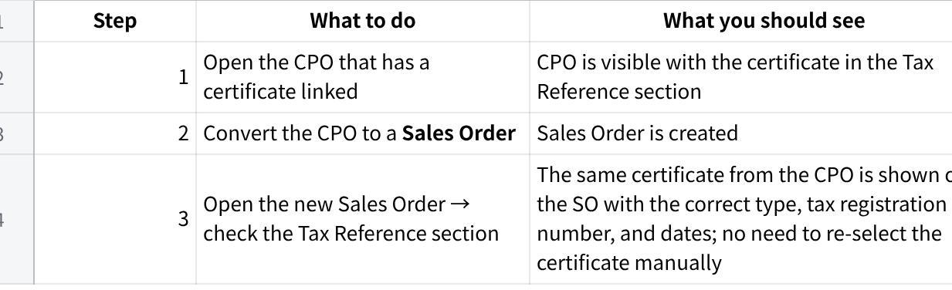
点击图片可查看完整电子表格
Your result:
- Pass
- Fail
- Issue
Tested by: Tam
Date: 26/5/26
Notes: Guan Huat

Test 32 — SO Submit Blocked — C3 Missing Required Attachments
Who tests this: [Sales Manager] or [Finance / Logistics]
Channel: FE + Chatbot
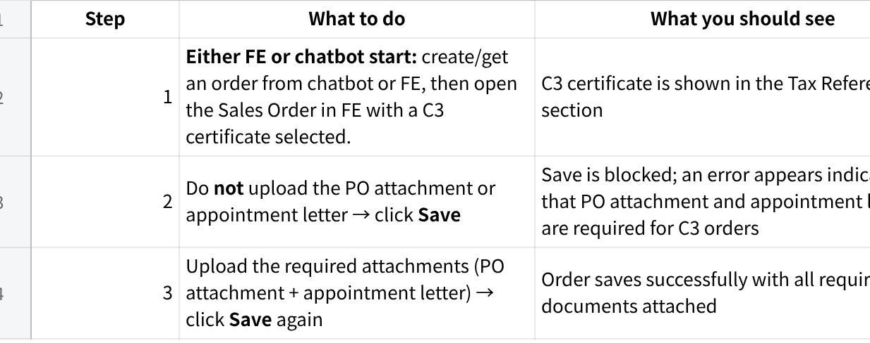
点击图片可查看完整电子表格
Your result:
- Pass
- Fail
- Issue
Tested by: Tam
Date: 26/5/26
Notes: Guan Huat

Test 33 — SO Submit Blocked — Item HS Code Not in Certificate
Who tests this: [Sales Manager] or [Finance / Logistics]
Channel: FE + Chatbot
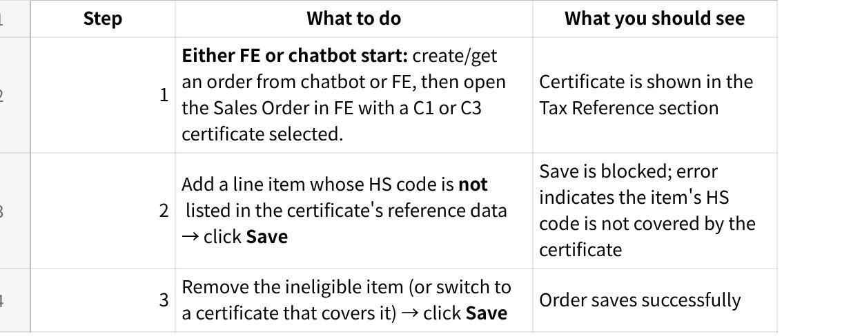
点击图片可查看完整电子表格
Your result:
- Pass
- Fail
- Issue
Tested by: Tam
Date: 26/5/26
Notes:

Results Summary
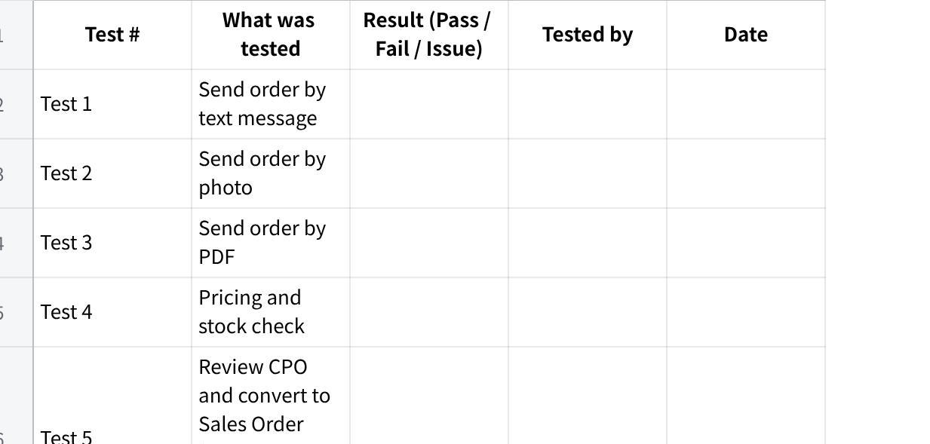
点击图片可查看完整电子表格
Total: 36 tests
点击图片可查看完整电子表格

Overall Feedback
Any general comments about the system?

Any features that were confusing or difficult to use?

Sign-Off
By signing below, the Holsen team confirms that UAT has been completed and the results above are accurate.
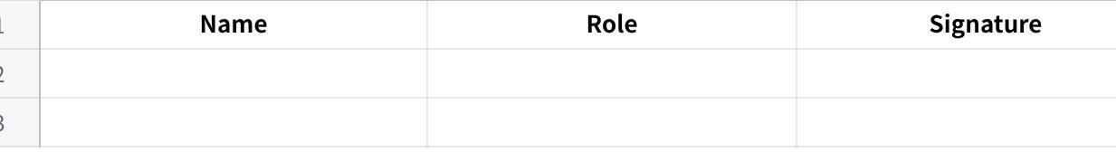
点击图片可查看完整电子表格
Overall outcome:
- Approved — Ready to go live
- Conditional — Go live with the following items to fix first:
Conditions:
- Not approved — Further fixes required before go live

